

**National University of Sciences & Technology**

**School of Electrical Engineering and Computer Science**

**Department of Computing**

**CS-344: Web Engineering (3+1) BESE-9AB Fall 2020**

**ASSIGNMENT # 1**

**SUBMITTED TO: Dr. Qaiser Riaz**

**SUBMITTED BY:**

1. **Usama Ejaz (247644)**
2. **Ahmad Bilal (245987)**
3. **Hammad Ahmad (266578)**

**Date of Submission: 8th November, 2020**

**Description of the Assignment:**

HTML is the standard markup language which is widely used over world wide web to create web pages. Over the passage of time, various versions of HTML have been released. HTML5 is the latest version of HTML which is adapted by W3C in 2008.

**Your task**  
Write a detailed report on HTML5 including:

* What are the new features/tags introduced in HTML5. Following must be included in the report:
  + New semantic elements like <header>, <footer>, <article>, and <section>.
  + New attributes of form elements like number, date, time, calendar, and range.
  + New graphic elements: <svg> and <canvas>.
  + New multimedia elements: <audio> and <video>.
* A comparison with HTML4: What is no more supported in HTML5
* It’s a group task
* Report must include at least 10 pages.
* **Use the assignment template shared on LMS.**A submission in any other format will result into deduction of marks.
* The title page of the report must include assignment number, names and IDs of group members, and Class with section (e.g. BESE-9A)
* Each group must submit only a single report.

**Important: Feel free to browse online literature to search related contents but your report must be your own work. A similarity index of above 15% will get a straight ‘0’.**

Contents

Semantic Tags introduced in html 5 4

Header Tag <header> 4

Footer Tag <footer> 5

Article Tag <article> 7

Section Tag <section> 8

Nav Tag <Nav> 9

New attributes of form elements introduced in Html 5 11

<Number> 12

<Placeholder> 12

<List and Datalist> 13

<autofocus> 13

<autocomplete> 14

<formmethod> 14

<novalidate> and <formnovalidate> 14

<form> 14

<name> 15

<date> 16

<time> 17

<range> 18

New graphic elements introduced in Html 5 20

<svg> 20

<canvas> 20

New Multimedia Elements introduced in Html 5 21

<audio> 21

<video> 22

Differences between HTML5 and HTML4 ..………………………………………………………………………………………………….. 24

HTML5: What’s New in the Latest HTML Release?

Authors: Usama Ejaz, Hammad Ahmad, Ahmad Bilal

# Semantic Tags introduced in html 5

The following semantic tags have been introduced in html (Penland, n.d.). We’ll discuss most of the mentioned tags below. The elements that are added by html5 are:

* header
* main
* nav
* article
* section
* aside
* address
* footer

# Header Tag <header>

## Description

Header tag usually contains the introductory material of a webpage. It usually comprises of navigational and introductory content. More commonly, header tags are used as a placeholder for a website’s logo, a search bar or other components. Although the header tag is most commonly used only once in a webpage but it can also be used to specify the header of an article, section or any other piece of content on the page.

## Usage

No tag omissions are allowed. The starting and ending tags are both required. A <header> element should be a descendent of an <address>, <footer> or <header> element. The <header> element doesn’t introduce a new section, it is supposed to comprise of a section’s heading; usually h1 – h6 tags.

## History

The <header> tag was called <head> in the previous versions of HTML. It was actually existant for a long time. It was later introduced in HTML5 with a new name i.e. <header>

## Example

Below is an example of <header> tag.

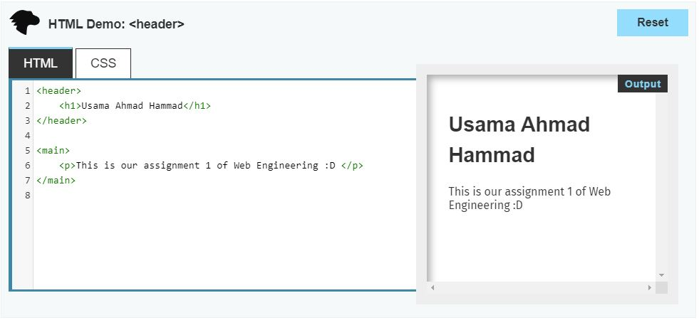

## Compatibility

Below is the compatibility information regarding <header> tag.

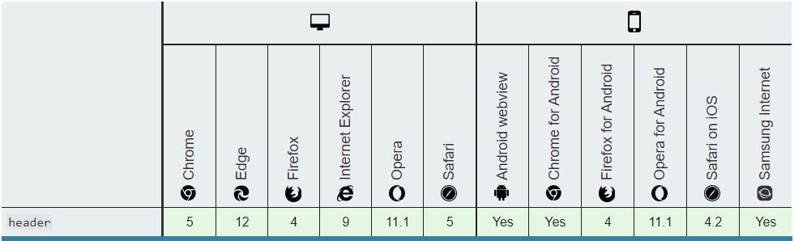

# Footer Tag <footer>

## Description

The <footer> component is a basic component used to recognize the footer of a page, report, article, or area. A <footer> normally contains copyright and author data or navigational links relating to the content of the parent component.

## Usage

No tag omissions are allowed. The starting and ending tags are both required. A <footer> element should be a descendent of an <address>, <footer> or <header> element. The <footer> element doesn’t introduce a new section, it is usually comprised of an <address> element.

## Example

Below is an example of <footer> tag.

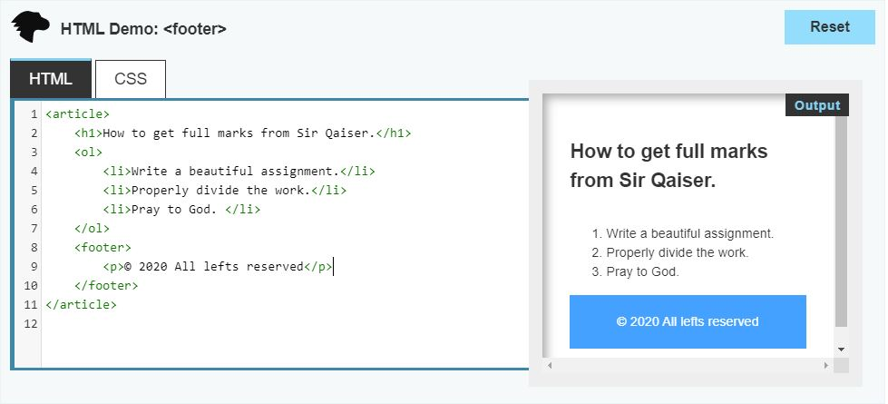

## Compatibility

Below is the compatibility information regarding <footer> tag.

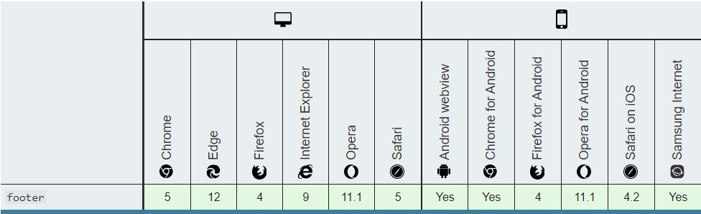

# Article Tag <article>

## Description

The <article> component comprises of an independent structure; usually in a report, page, application, or site, which is expected to be completely reusable. For example, a gathering post, a magazine or paper article, or a blog passage, an item card, a client submitted remark, an intuitive gadget or contraption.

## Usage

No tag omissions are allowed. The starting and ending tags are both required. An <article> should not be a descendent of an <address> tag. Typically, <article> element includes a heading (h1 – h6) to identify an article.

## Example

Below is an example of the <article> tag.

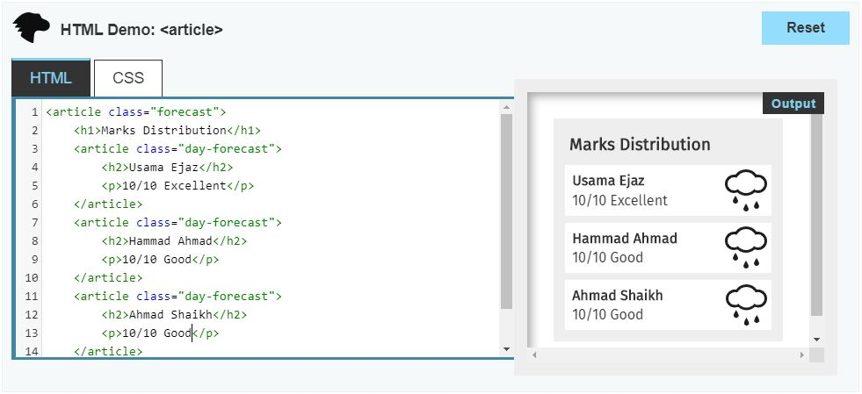

## Compatibility

Below is the compatibility information regarding <article> tag.

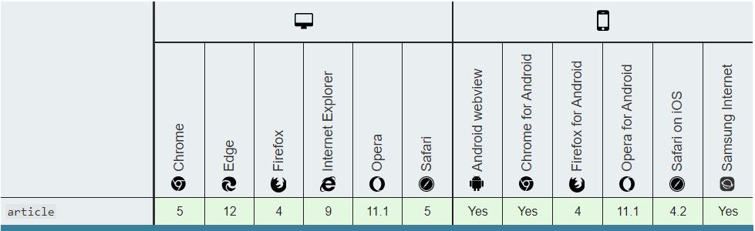

# Section Tag <section>

## Description

The <section> component is utilized to distinguish content that is a significant sub-part of a bigger page. For instance, on the off chance that you've posted a long-structure digital book in HTML design, it is sensible to envelop every part by a section component. In the same manner, in the event that you have a sidebar that contains four areas – advertisements, a search bar, related posts, and a bulletin information exchange structure – it would be alright to enclose every one of these four segments by <section> tag.

## Usage

There is some disarray about when to utilize a section and when to utilize a div. Here's a decent dependable guideline for you to know when to utilize each:

* Utilize a div in case you're wrapping up some content simply to make it simpler to style it or to make it simpler for some JavaScript code to interact with it.
* A guideline is that a section should logically appear in the outline of a document.
* <section> should not be used in place of <div>. That is; it should not be used as an generic container to wrapper.

No tag omissions are allowed. The starting and ending tags are both required. A <section> should not be a descendent of an <address> tag. Typically, <section> element includes a heading (h1 – h6) to identify it.

## Example

Below is an example of the <section> tag.

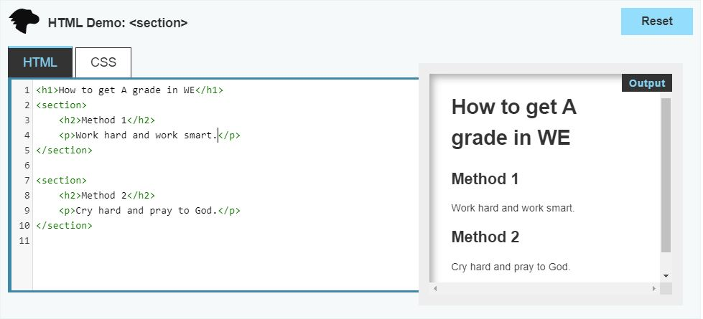

## Compatibility

Below is the compatibility information regarding <section> tag.

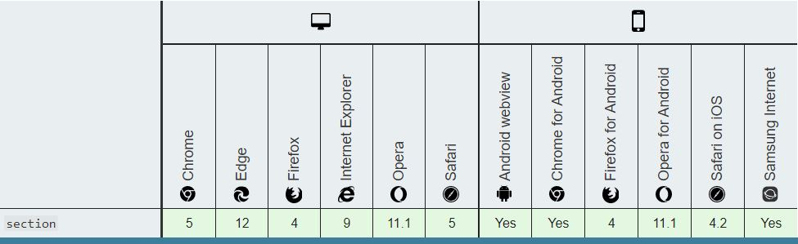

# Nav Tag <Nav>

## Description

<nav> Tag is used to show a part of web page whose main aim is to provide us with navigational links. The links may point to the same document or they may point to other documents. For example, menus and indexes.

## Usage

No tag omissions are allowed. The starting and ending tags are both required. It can be a descendent of any element that accepts flow content. <nav> is mainly used for a big block containing navigation links. For example <footer> contains many navigation links. A webpage can have many <nav> elements.

## Example

Below is an example of the <nav> tag.

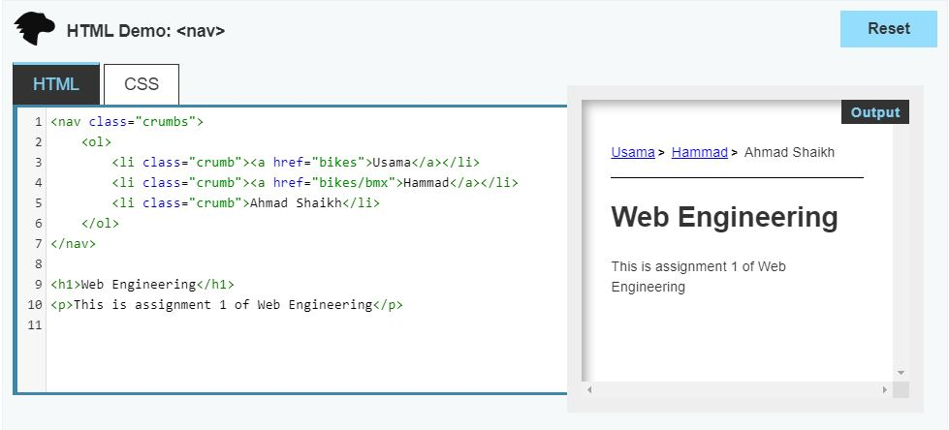

## Compatibility

Below is the compatibility information regarding the <nav> tag.

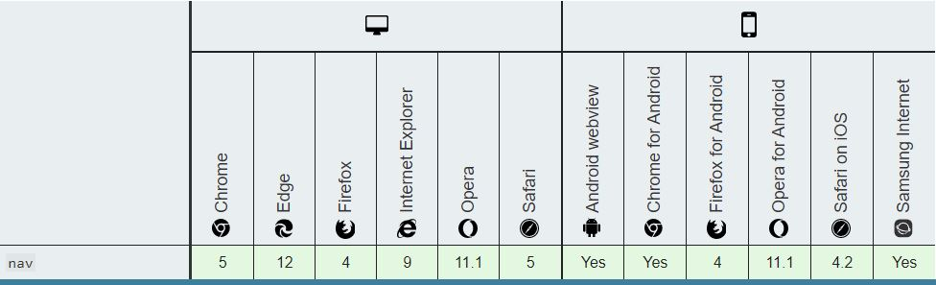

# New attributes of form elements introduced in Html 5

Following are the new attributes that are included in HTML5:

* Number
* Date
* Time
* Calendar
* Range
* Placeholder
* List & datalist
* Autofocus
* Autocomplete
* Formmethod
* Novalidate
* Formnovalidate
* Form
* Name

## <Number>

This attribute let the user type number in the input element within a specific range.

### Code:

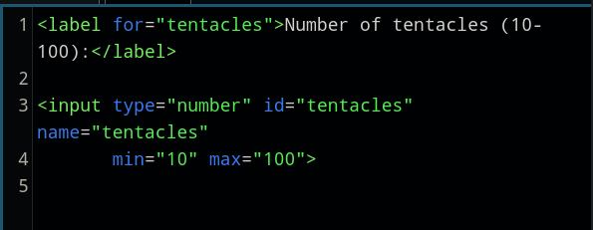

### Output:

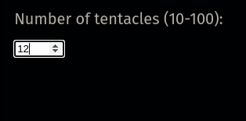

## <Placeholder>

This attribute allows us to set placeholder text in the webpage.

like in the below diagram. In the HTML4 we have to use the value attribute to set the placeholder.

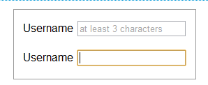

### Code for placeholder attribute:



## <List and Datalist>

This attribute is used to display a list of options or suggestions with an input field. It’s value should be the same as the id of the datalist that is in the same document.

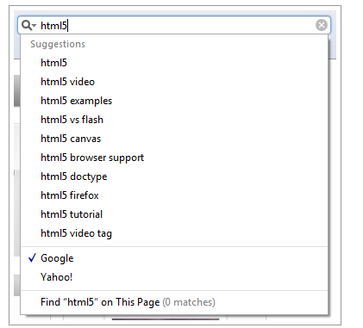

## <autofocus>

This attribute creates a bounding box across the input area that focus our attention there. And when we click anywhere else the bounding box is removed. That’s why it’s called the autofocus attribute.

We can use this in code as follows:



Like it creates a bounding box on the input.



## <autocomplete>

This attribute is used to display suggestions related to the earlier input the user has typed before.

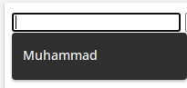

This is a boolean attribute that is enabled by default but you can disable it by using following code.



## <formmethod>

It specifies which HTML method would be use to submit the form data

## <novalidate> and <formnovalidate>

These two attribute are also boolean type attribute and indicates that it’s not necessary to validate the form after submission.



Formnovalidate attribute can only be used with submit or image input based types. while the novalidate attribute is only used on form elements.

## <form>

It is used to link input, textarea or select elements with the form. This form attribute shows that at any time these three elements can be moved away from the form without any problem means it doesn’t need to be a child element of form.



## <name>

This attribute is used to specify the name of a form element like first name, last name.

### Code:

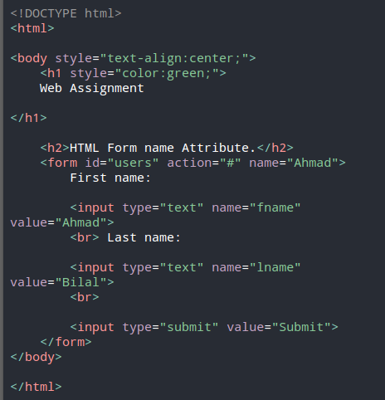

### Output:

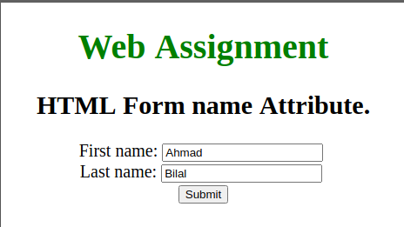

## <date>

This attribute is used to specify date in the form.

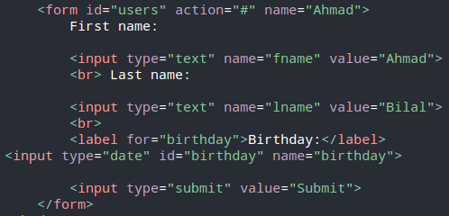

### Output:

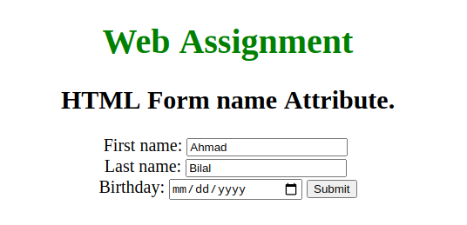

## <time>

This attribute allows the user to choose time.

### Code:

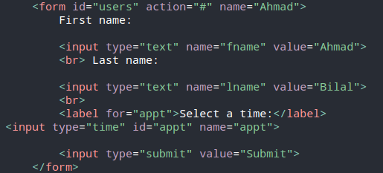

### Output:

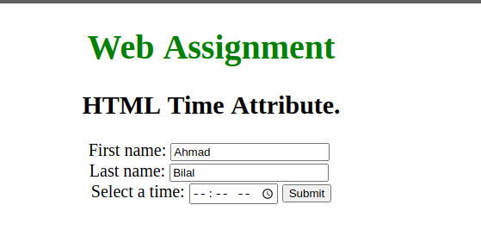

## <range>

This attribute allow us to choose a range of values in the html document.

### Code:

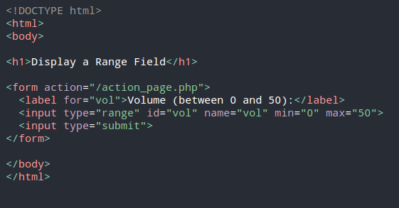

### Output:

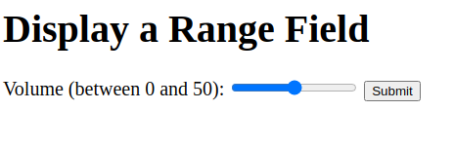

# New graphic elements introduced in Html 5

## <svg>

SVG stands for Scalable Vector Graphics. It is used to display graphics on the page.

### Code:

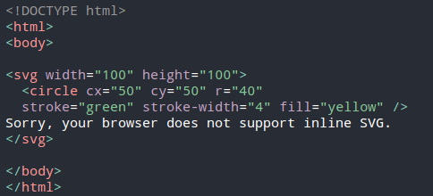

By using this code a circle would be displayed on the screen.

### Output:



## <canvas>

The canvas element is also used to display graphics on the screen. But javascript can only be used to draw those graphics as it is only a container for graphics.

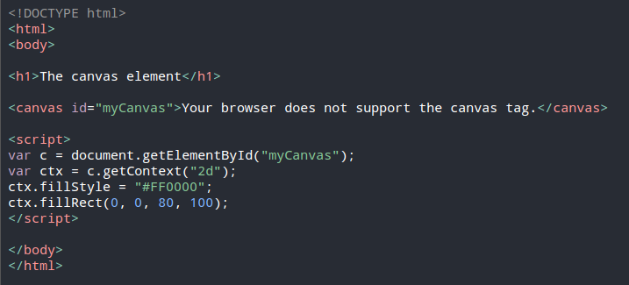

### Display:

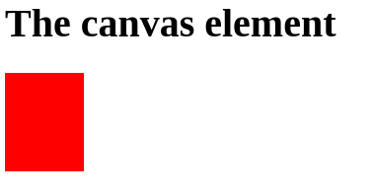

# New Multimedia Elements introduced in Html 5

## <audio>

This tag is used to display audio content on the web page such as music.

### Code:

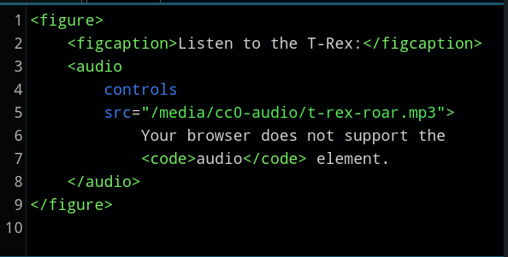

### Display:

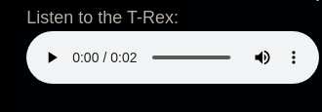

## <video>

This attribute is used to display video on the web page which can also support video playback. It can also be used to embed audio but the specific audio element would be more appropriate.

### Code:

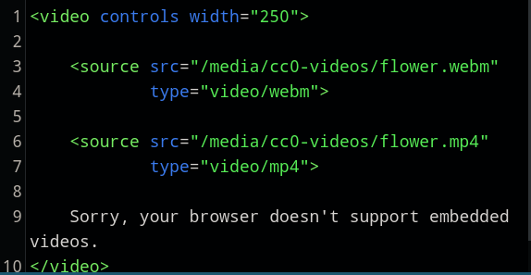

### Output:



# Differences between HTML5 and HTML4

HTML5 is the latest version of the markup language HTML. It is used for presenting and structuring content over the internet. HTML5 was released on January 22nd, 2008. It’s major goals were to improve the language in terms of readability for humans and consistency for computers. HTML5 also introduced modern multimedia hangelling to the markup language.

HTML5 is more simple as compared to HTML4, it has better error handling, produces more consistent results across different web browsers, has multimedia support. HTML5 is constantly changing with addition and removal of tags

Many new “tags” were also included. For native handling of multimedia like video, audio and image tags like <video>, <audio> and <canvas> were added along with many others. Following is the list of new tags introduced .

### *<article>*

This tag is used to write independent and self-contained content. Which could be distributed independently separate from the rest of the website

|  |
| --- |
|  |

### *<aside >*

This tag is used for content that is separate from the rest of the page. It is mostly used for side bars

|  |
| --- |
|  |

### *<audio>*

This is for native support for audio files

|  |
| --- |
|  |

### *<canvas>*

This creates an empty rectangle on the page for graphics. Javascript is used to draw the graphic

|  |
| --- |
|  |

### *<command>*

This is used to link javascript code to an html element

### *<datalist>*

The datalist tag is used to make a dropdown menu.

|  |
| --- |
|  |

### *<details>*

Used to provide extra information that the user can expand or contract on demand

|  |
| --- |
|  |

### *<embed>*

This tag creates a container for an external resource. Something present outside the current website

|  |
| --- |
|  |

### *<figure>*

It is used to add an image and mose caption to the page

|  |
| --- |
|  |

### *<footer>*

Tag for the content at the bottom of the webpage

|  |
| --- |
|  |

### *<header>*

Container for content at the top or beginning of the webpage

|  |
| --- |
|  |

### 

### *<mark>*

Highlight a part of text

|  |
| --- |
|  |

### *<meter>*

Used to indicate progress or consumption

|  |
| --- |
|  |

### *<nav>*

Used to contain navigation links

|  |
| --- |
|  |

### *<output>*

Display output dynamically

|  |
| --- |
|  |

### *<progress>*

Indicate progress of download/upload

|  |
| --- |
|  |

### *<ruby>*

Used to annotate text

|  |
| --- |
|  |

### 

### *<time>*

Used to write formatted time

|  |
| --- |
|  |

### *<video>*

Tag to hold video multimedia

|  |
| --- |
|  |

### *<wbr>*

Used to indicate the position where the text should break in case.

|  |
| --- |
|  |